Learning force control for contact-rich manipulation tasks with rigid position-controlled robots(高精度装配)

作者联系方式：beltran[at]hlab.sys.es.osaka-u.ac.jp

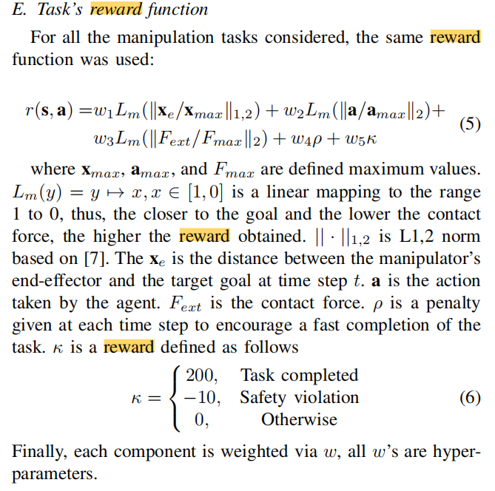

1. DeepMimic： Example guided deep reinforcement learning of physics based character skills

人形机器人技能学习

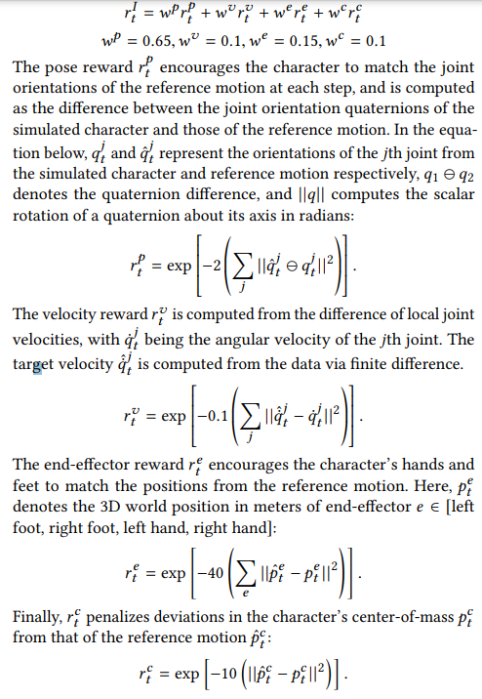

1. DDPGfD(装配问题)

